# Multi Choice Answers Task 6: Test – Variation, Mutation and Evolution (10 marks)

1. Mutations that occur in body cells are called
2. germline

## somatic

1. gene
2. autosomal
3. Genetic traits that are determined by two or more pairs of genes are
4. multi-allelic.
5. co-dominance.

## polygenic

1. incomplete dominance
2. Skin colour is affected by

## exposure to ultra violet light and genotype

1. exposure to infra-red light and phenotype
2. just genotype
3. just environmental factors
4. Thalassemia results in

## having anaemia with high iron levels

* 1. having anaemia with low iron levels
  2. the need for iron tablets to supplement iron reserves
  3. a dominant disease resulting in defects in haemoglobin formation

1. Populations that have become genetically isolated from one another
2. usually have the same gene frequencies for physical characteristics
3. are not subject to random genetic drift
4. are subject to similar environmental selection pressures

## may develop into different subspecies that are unable to interbreed

1. A mutation is a sudden change in the structure of a gene. Scientists link mutations to the process of natural selection very closely. Mutations
2. always produce beneficial variations upon which natural selection can act

## are of importance to natural selection only if they can pass from generation to generation

1. will improve the survival chances of an individual
2. result in random genetic drift
3. Tay-Sachs Disease is a hereditary disorder of

## lipid metabolism

1. protein metabolism
2. carbohydrate metabolism
3. vitamin D synthesis
4. Humans throughout the world are considered by scientists to belong to a single species because they all
5. make use of manufactured tools

## can interbreed to produce offspring

1. have binocular colour vision
2. use language and symbols as a means of cultural transmission
3. 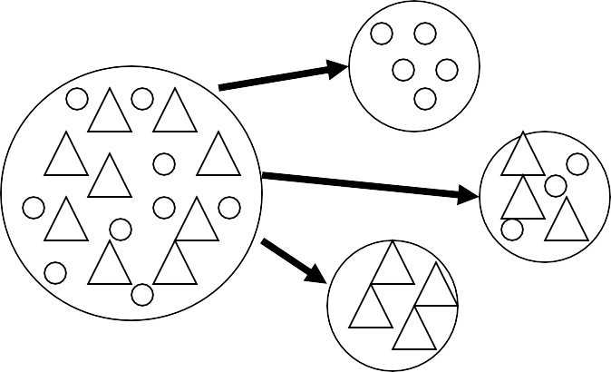These diagrams below indicate
4. migration

## founder effect

1. genetic drift
2. geographical barrier
3. Which best describes the genotype for sickle cell anaemia?
4. HAHS
5. hh

## HSHS

## Hh